**ASSIGNMENT -1**

**Install Power BI Desktop and share the final screenshot of the report view page which appears when power desktop starts**

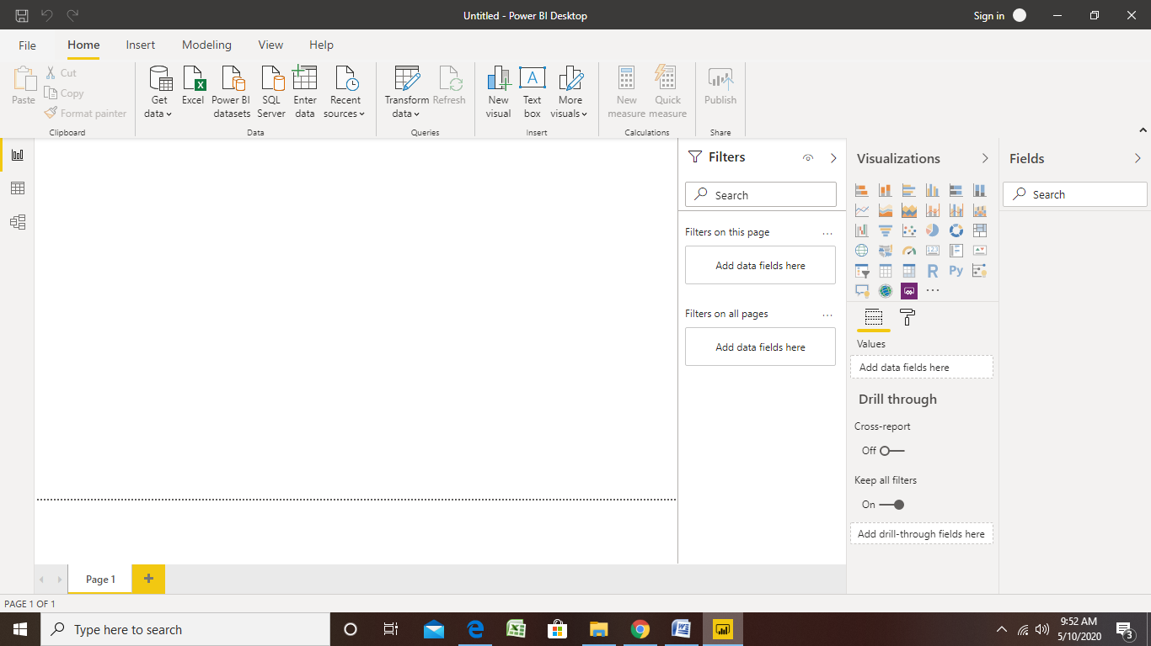

**Prepare a document and with the following screenshot − Report View –**

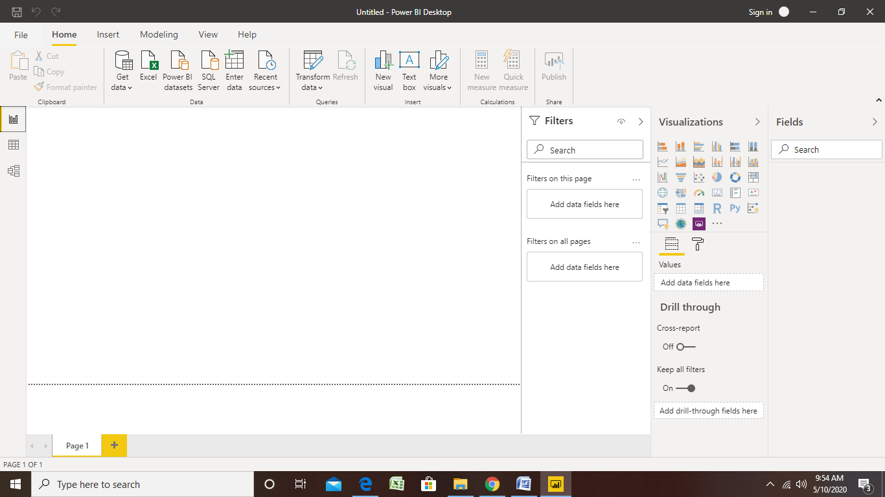

**Data View –**

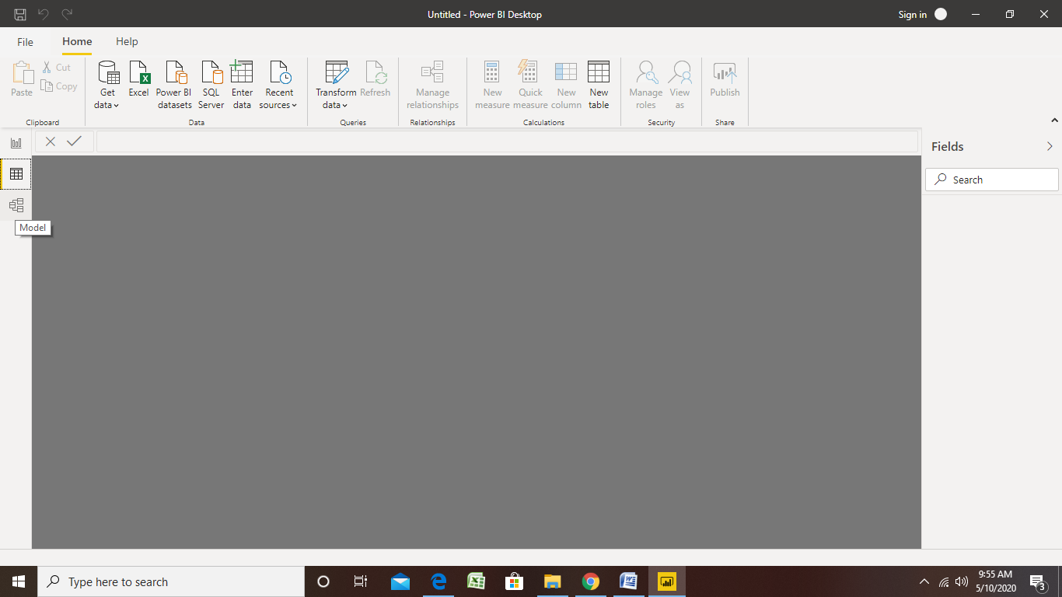

**Model View –**

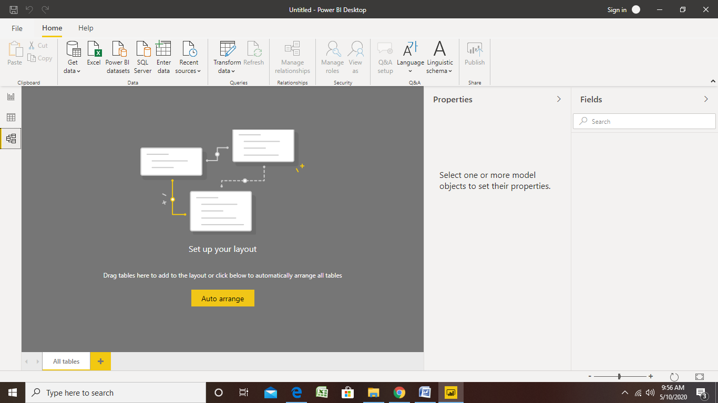

**Power Query Editor –**

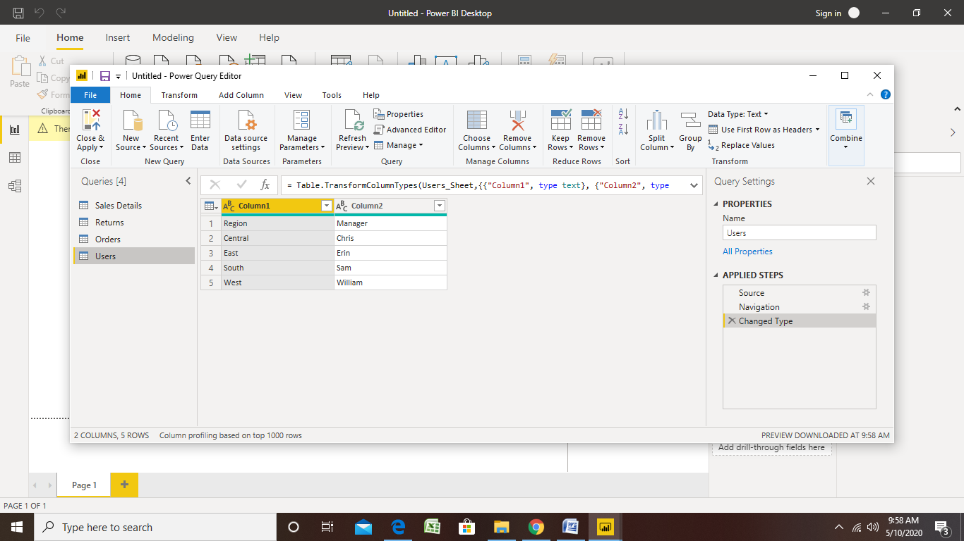

**Advance Editor**

